IV Swinger

User Guide

Rev 1.02 – 12/03/2015

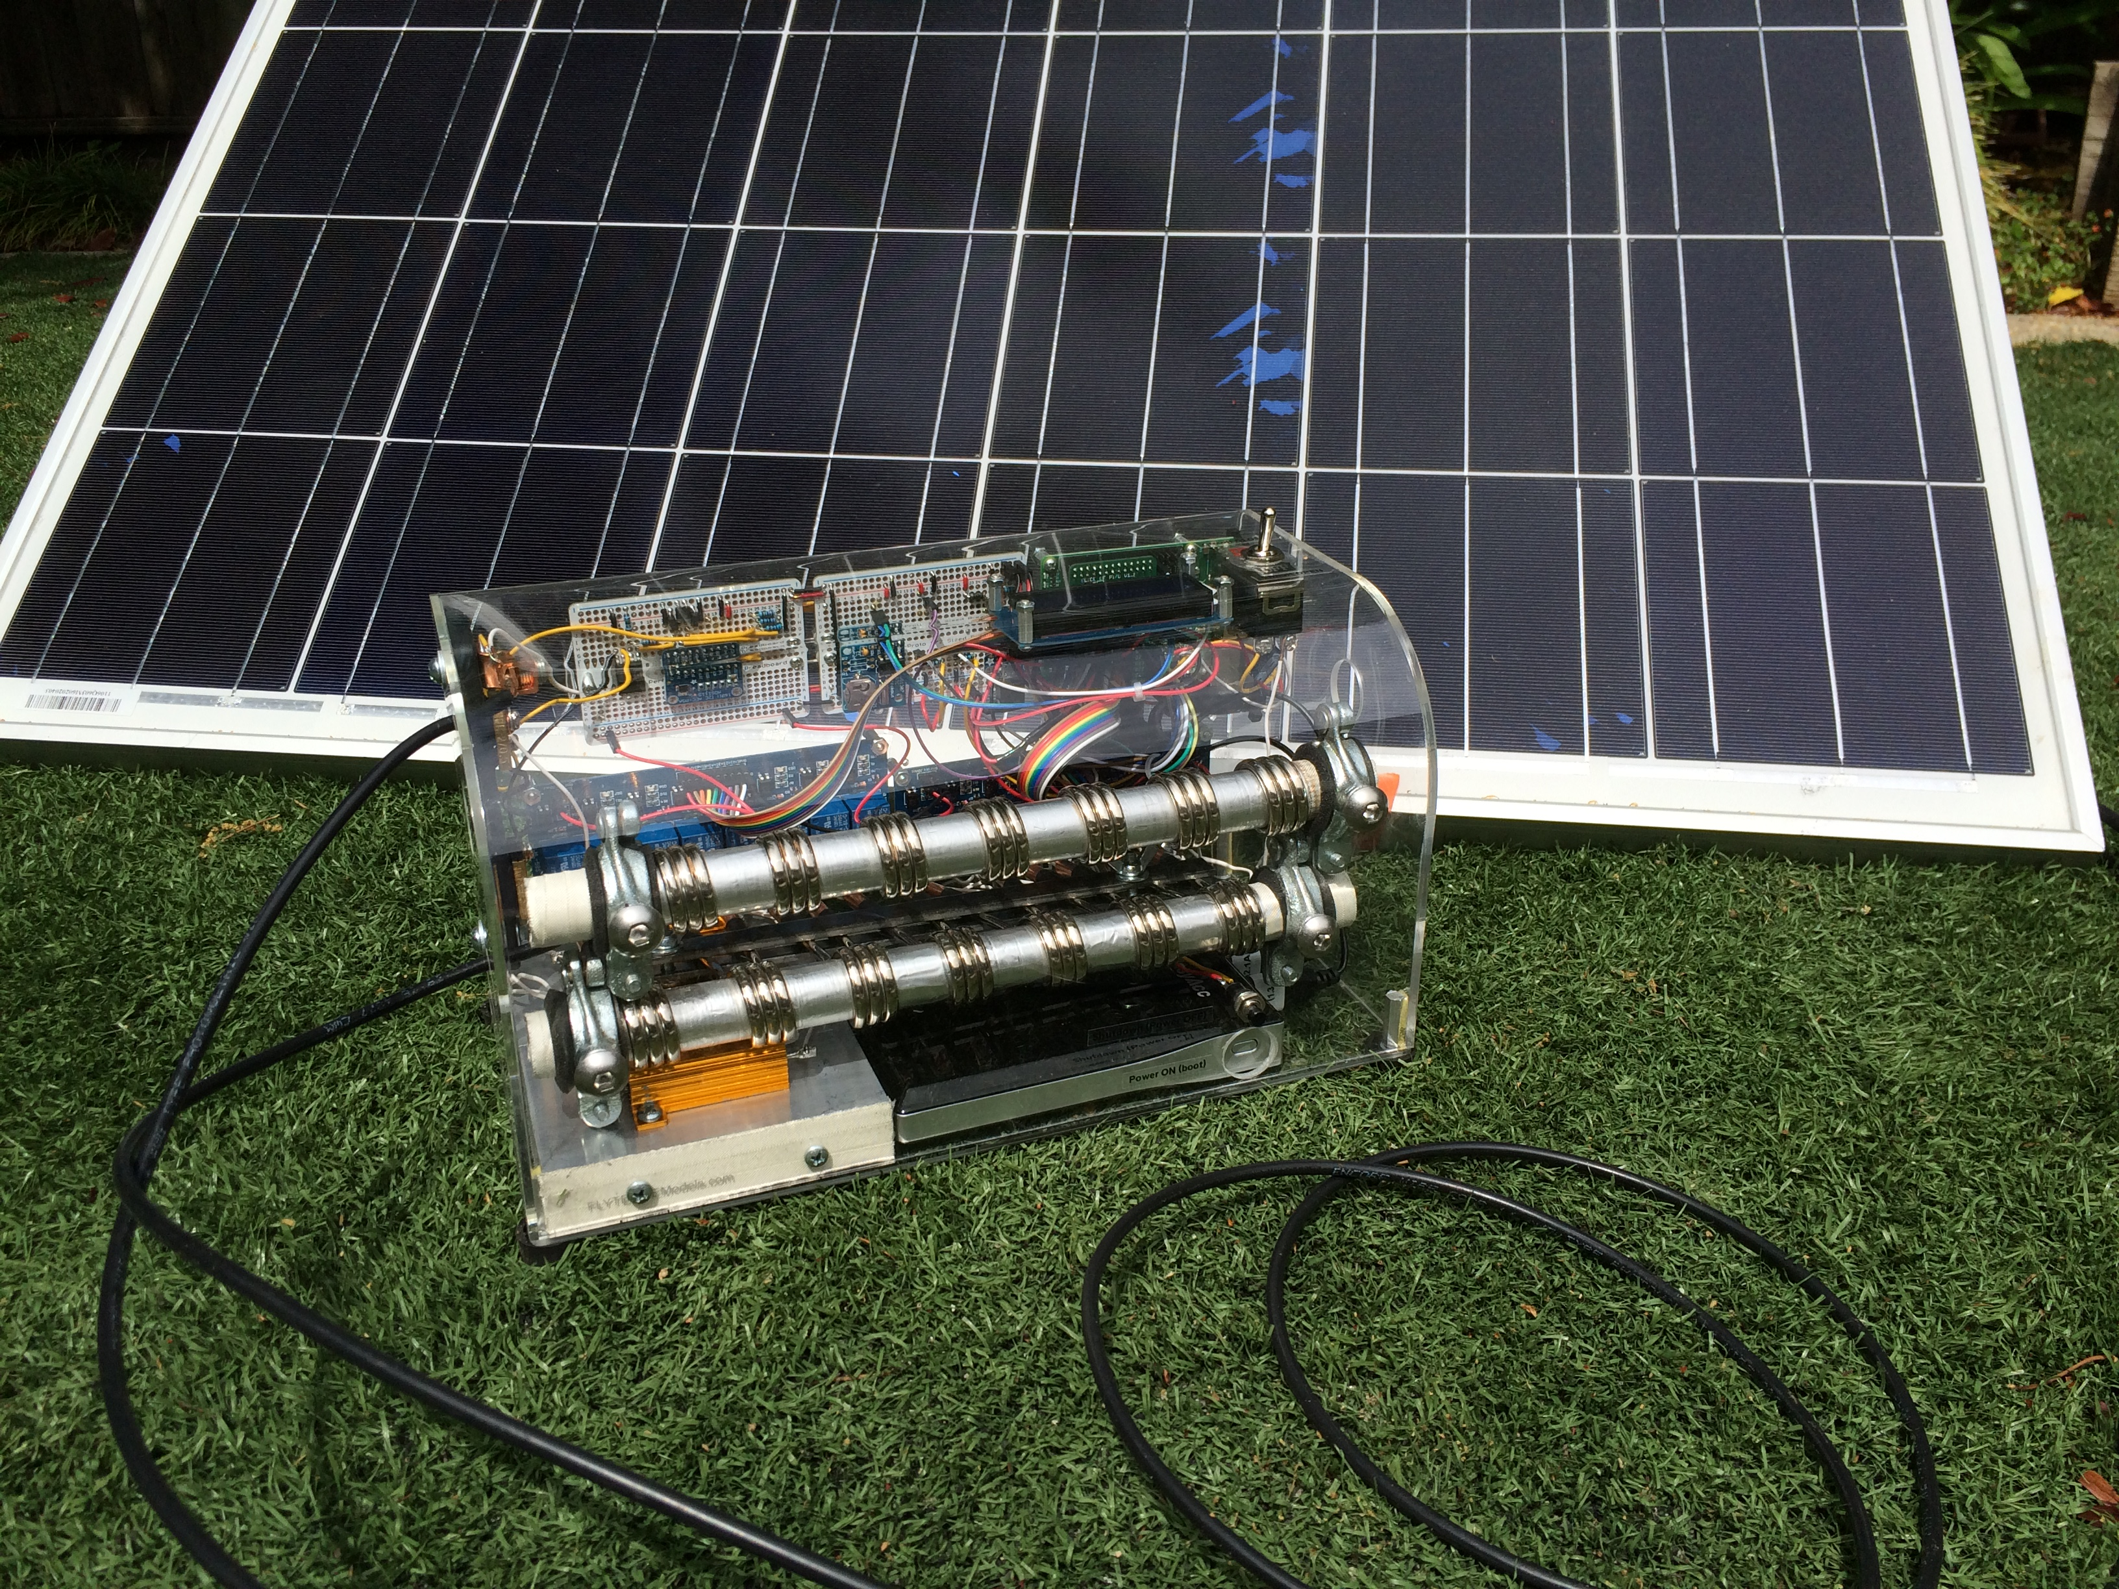

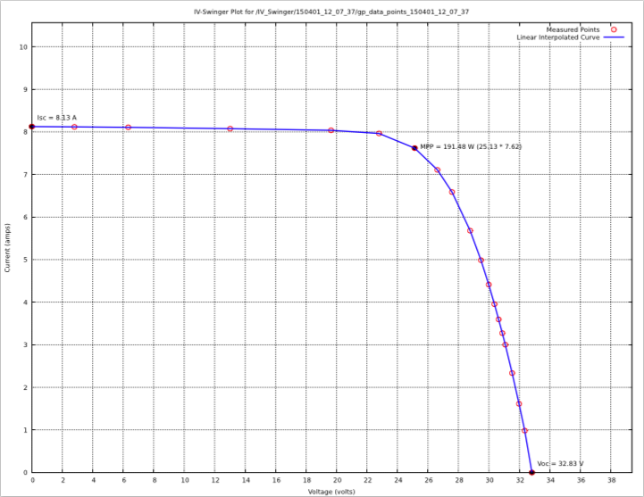Copyright (C) 2015 Chris Satterlee

IV Swinger is an open source hardware and software project.

Permission to use the hardware design is granted under the terms of the TAPR Open Hardware License Version 1.0 (May 25, 2007) - <http://www.tapr.org/OHL>

Permission to use the software is granted under the terms of the GNU General Public License v3 - <http://www.gnu.org/licenses>.

Current versions of the license files, documentation, Fritzing file (hardware description), and software can be found at:

<https://github.com/csatt/IV_Swinger>

**YouTube Demo Video**

[**https://www.youtube.com/watch?v=xNytkONOcW0**](https://www.youtube.com/watch?v=xNytkONOcW0)

**Quick Start**

1. **Insert 1-4 thumb drives into the Raspberry Pi USB slots.** The slots are located on the right end of the IV Swinger near the top. The results will be written to all drives that are inserted.

2. **Make sure the toggle switch is in the OFF (Circuit OPEN) position.**

3. **Connect the PV panel to the cables.** If the panel does not have the standard MC4 type of connector, take care to connect the positive (+) cable from the panel to the female IV Swinger cable and the negative (-) cable from the panel to the male IV Swinger cable.

4. **Boot the IV Swinger by powering on the battery pack.** The button is accessible through the hole on the front of the box just below the black pushbutton. The boot takes a little less than 30 seconds and then a welcome message is displayed on the LCD.

5. **Establish the desired PV panel conditions.** i.e. angle, shading, etc. Also at this point, take any other desired measurements such as insolation and temperature.

6. **Turn the toggle switch to the ON position (Circuit CLOSED).** The IV Swinger will increment the load using the relays, measuring the current and voltage at each point. You can hear each relay click when it switches its load into the circuit; its LED is also illuminated.

7. **Return the toggle switch to the OFF position (Circuit OPEN) when prompted.**

8. **Repeat the previous 3 steps as needed.** It is OK to disconnect the PV panel and connect a different one without shutting down the IV Swinger.

9. **Press and hold the black Shutdown (Power OFF) button for 3 seconds.** This gracefully shuts down the Raspberry Pi and powers down the system. Do not power off using the button on the battery pack since that could cause file system corruption (see NOTE at the bottom of the page, however).

10. **Remove the USB drive(s).** The output files will be in the /IV_Swinger folder. Each run's files are in a sub-folder named for the date and time that the measurements were taken. The raw data is in the data_points_yymmdd_hh_mm_ss.csv file that can be read into Excel or another spreadsheet application. The gp_data_points_yymmdd_hh_mm_ss.pdf file contains a graph generated with Gnuplot. There are copies of all of the CSV files in the /IV_Swinger/csv folder and copies of all of the PDF files in the /IV_Swinger/pdf folders since that can sometimes be more convenient. NOTE: It is probably OK to remove the USB drive after a run to peek at the results and then re-insert it before the next run – but make sure the LCD is displaying the “Turn switch ON to start again” message before removing it.

**NOTE:** If the LCD displays a message that begins with “Unexpected error:” or if the IV Swinger is unresponsive, the only recourse is to power down using the button on the battery pack.

**Introduction**

The IV Swinger automates the process of tracing the IV curve of a single photovoltaic (PV) solar panel.

The IV curve is a graph of current versus voltage for various load values driven by the PV panel. A typical IV curve of an unshaded PV panel looks like this:



At one extreme there is the short-circuit current (Isc), which is the current delivered by the PV when the leads are directly connected to each other (in which case the load is 0 ohms and the voltage is 0 volts). At the other extreme is the open-circuit voltage (Voc), which is the voltage across the PV terminals when there is no connection between them (in which case the load is infinite and the current is 0 amps). Between these two points is a curve dependent on the load (resistance)

connected between the PV terminals. As seen above, the typical IV curve is a fairly horizontal line declining slightly from Isc as the voltage increases and then declining steeply when the voltage nears Voc. Power is the product of current and voltage. No power is delivered when the circuit is shorted (since the voltage is 0) and no power is delivered when the circuit is open (since the current is 0). The maximum power is delivered for the load value at the “knee” of the curve. One purpose of generating an IV curve is to determine the maximum power that a given panel can generate under a given set of conditions (such as insolation and temperature). Plotting the IV curves for different conditions including shading is an important lab exercise in courses teaching principles of photovoltaic operation

Manual generation of an IV curve is a fairly tedious (albeit educational) process. First the Isc and Voc values are measured with a multimeter. Then the PV panel is connected to a variable load. This can be a bank of light bulbs that may be switched into or out of the circuit. Or it can be a heavy-duty rheostat. The load value is incrementally changed, and at each point the meter is used to measure the current and voltage, which are recorded manually. Then the values are typed into a spreadsheet and plotted. Performing this process by hand at least once is a good way to get a real feel for what is going on. But it is time-consuming, subject to human error, subject to changing conditions, etc.

The IV Swinger is named for the process of “swinging out an IV curve”, which is how Gil Masters describes it in his CEE176B class at Stanford. The control of the IV Swinger is a Raspberry Pi model B+ single-board computer (SBC). Software on the Raspberry Pi controls relays that select or deselect (bypass) loads. The loads are immersion heating coils that have a similar resistance and wattage to the 100W DC light bulbs used in the CEE176B lab. There are also some higher resistance power resistors for the steep vertical part of the curve. It has built-in voltmeter and ammeter hardware that are read by the software at each load value. It records the values and writes them to a CSV file on one or more USB thumb drives. It also generates a plot of the IV curve using gnuplot and saves that as a PDF on the thumb drives.

**Visual Tour**

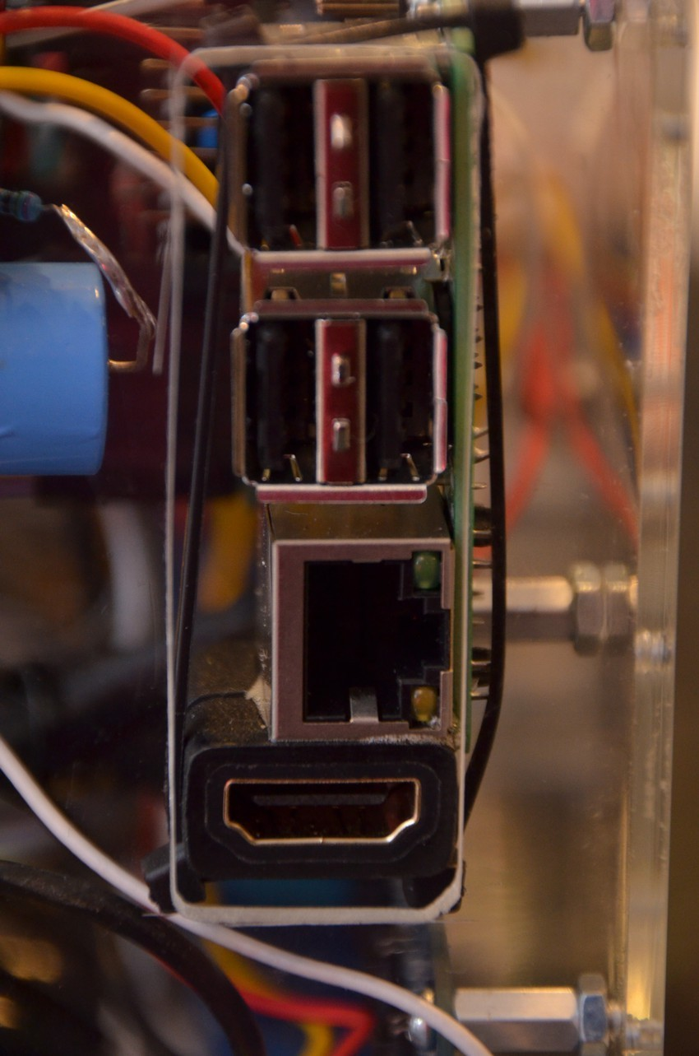

**Raspberry Pi Ports**

The Raspberry Pi SBC is mounted to the rear of the case in the upper right corner. The rectangular hole in the case exposes its four USB ports and its Ethernet port. The HDMI port is also made available just below the Ethernet port via a short extension cable. The Ethernet and HDMI ports are for development and debug only and are not needed for normal operation. The USB ports are used to plug in one or more thumb drives. The software creates a /IV_Swinger folder on all installed thumb drives and writes the results to sub-folders under /IV_Swinger. The thumb drives should be installed before the IV Swinger is powered on.

**Toggle Switch (Circuit OPEN / CLOSED)**

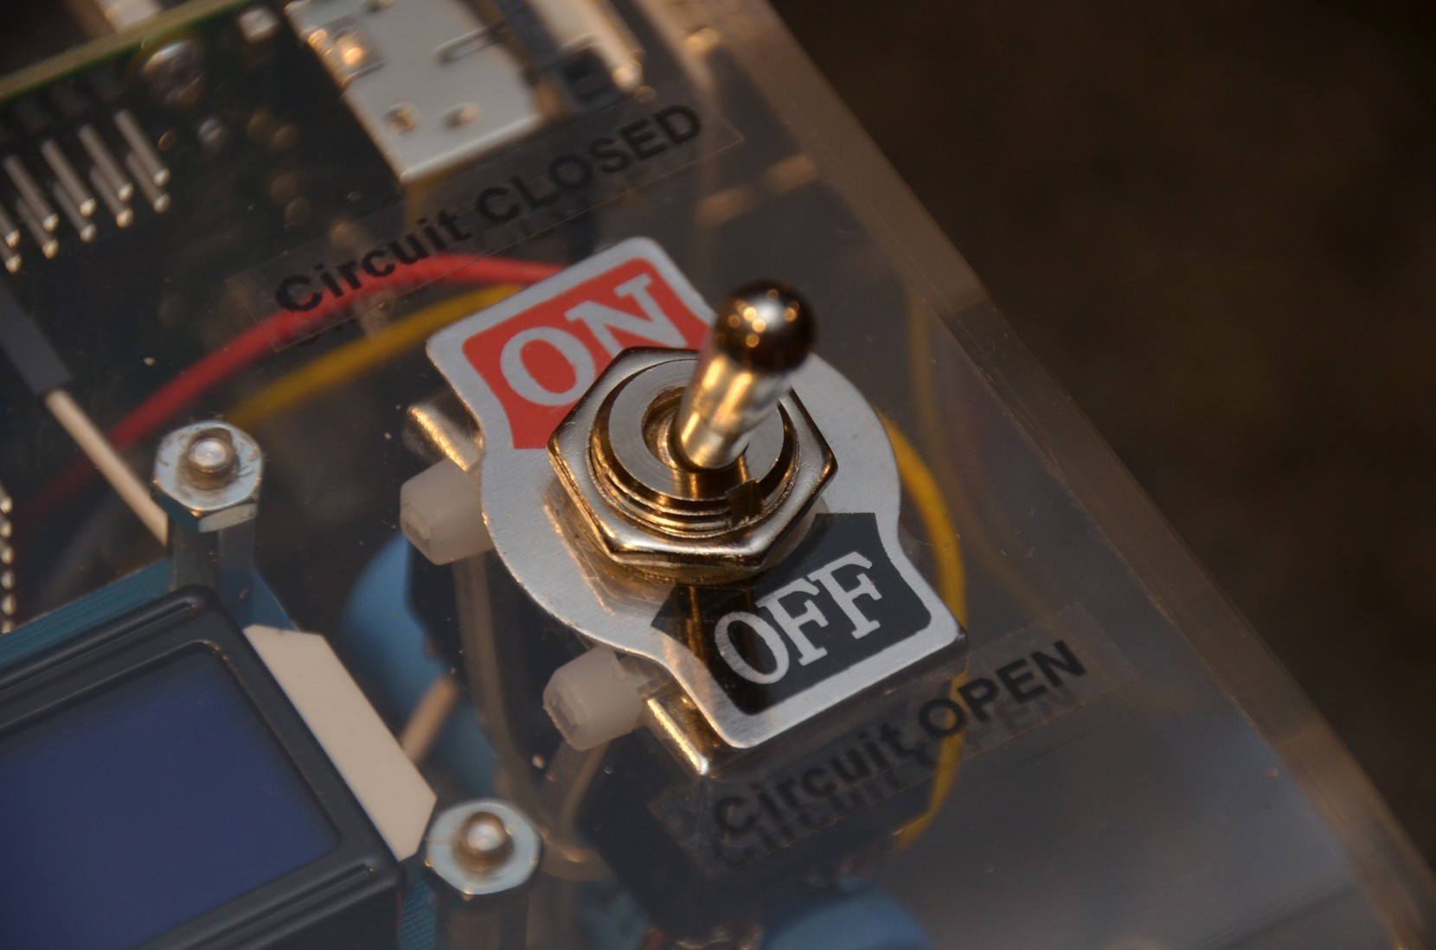The toggle switch on the top of the case is a double-pole single-throw (DPST) switch. When it is in the OFF position, the load circuit is open. When it is in the ON position, the load circuit is closed. The other side of the “double pole” is connected to the Raspberry Pi and is monitored by the software to sense

the state of the switch. The toggle switch should be in the OFF position before the IV Swinger is powered on and when connecting the PV cables. Messages on the LCD display prompt the user when to turn the switch on and when to turn it off again. The switch should always be in the

OFF position except for the short time that the IV curve is being measured. Leaving it in the ON position with a PV connected (even if the IV Swinger is powered off) can overheat and damage the relays.

**PV Connection Cables**

The cables coming out of the left side of the case connect to the PV panel. They have the standard MC4 connectors that most modern PV panels have on their cables. The female connector on the IV Swinger connects to the male (positive) connector from the PV panel. The male connector on the IV Swinger connects to the female (negative) connector from the PV panel.

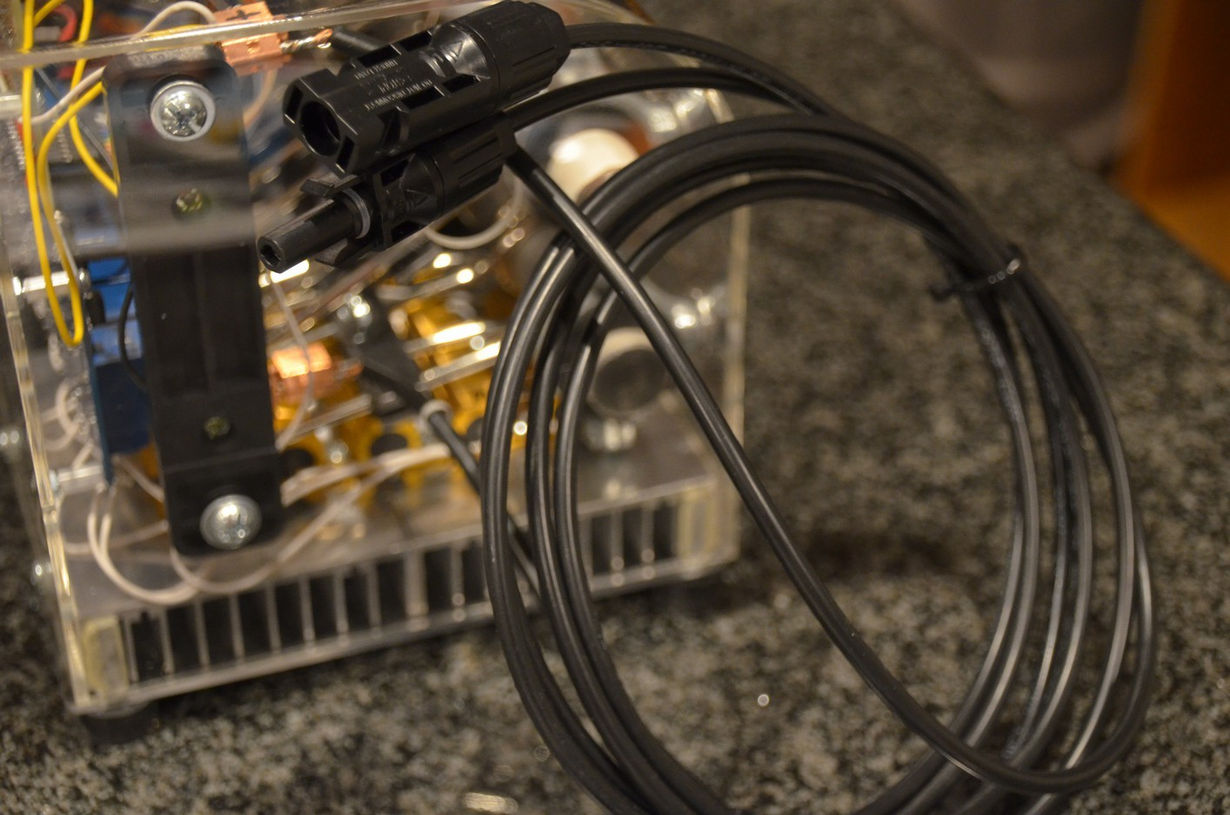

**Power On / Power Off buttons (Boot / Shutdown)**

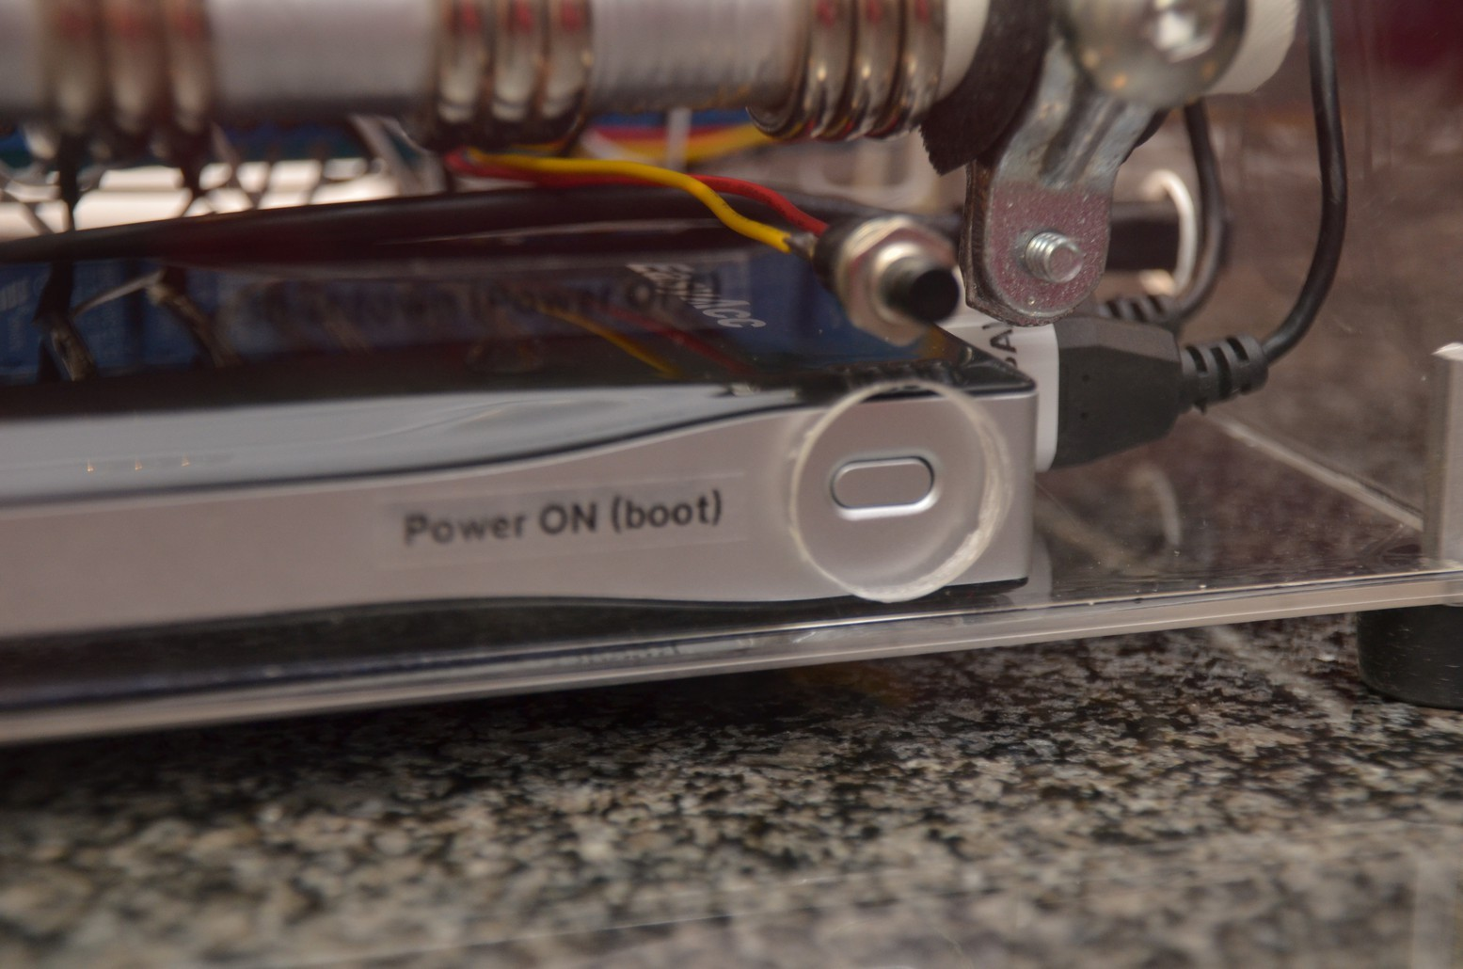The IV Swinger is powered by a 12000 mAh battery pack that sits at the bottom of the case

on the right end. The battery pack's power button is exposed through a round hole in the case. When

this button is pressed, the IV Swinger is powered on and the Raspberry Pi starts booting Linux. The boot

takes around 30 seconds, at which point the IV Swinger

software is automatically started.

As with any computer, ungracefully powering it off potentially can cause problems such as file system corruption. The black pushbutton switch above the battery pack should always be used to power off the IV Swinger. It is monitored by the software, which performs a graceful shutdown. To prevent accidental shutdowns, the switch must be held down for 3 seconds for the shutdown to occur. There is also an inactivity timeout of 10 minutes, at which point the IV Swinger automatically shuts itself down. A warning beep is emitted every second for the last 30 seconds before the auto shutdown (with a message on the LCD display). The only way to forestall the auto shutdown is to flip the toggle switch to the ON position and capture a trace.

**LCD Display**

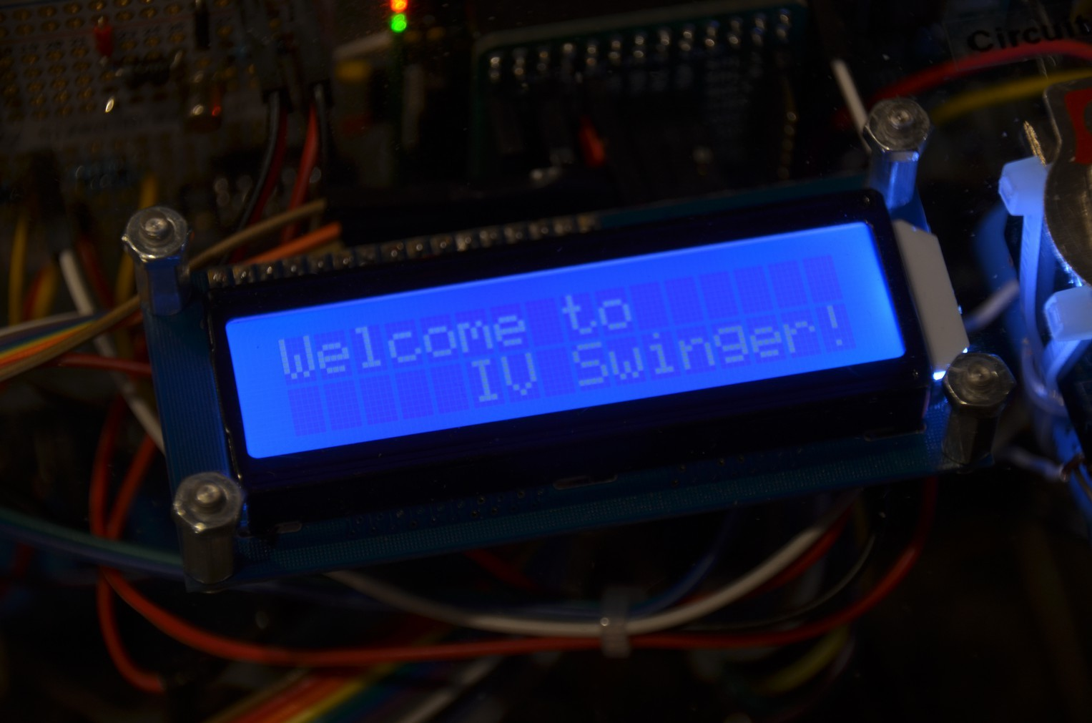The LCD display is on the top of the case next to the toggle switch. This display will light up, but will be blank during boot. When

boot is complete and the IV Swinger software starts, the LCD displays a “Welcome to IV Swinger!” message. After that the LCD displays instructions, messages, and data for the user to read. It is a small display, so some of these messages are scrolled.

**Piezo Buzzer and LCD Contrast Adjustment**

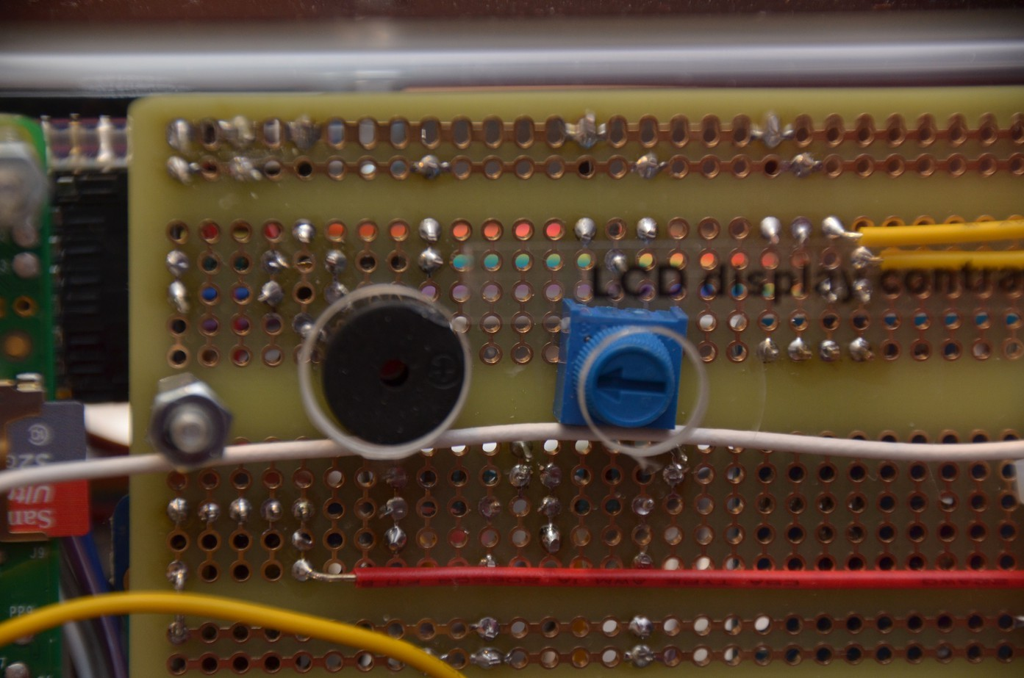There are two holes on the back of the case. The one on the left exposes the piezo buzzer. The piezo buzzer is used to generate loud beeps when the user's attention is needed. When you hear it beep, look at the LCD display for instructions.

The other hole exposes the LCD contrast adjustment potentiometer. If the LCD display is difficult to read, use a small screwdriver to turn this knob until the display is most legible.

**Battery Charger Port**

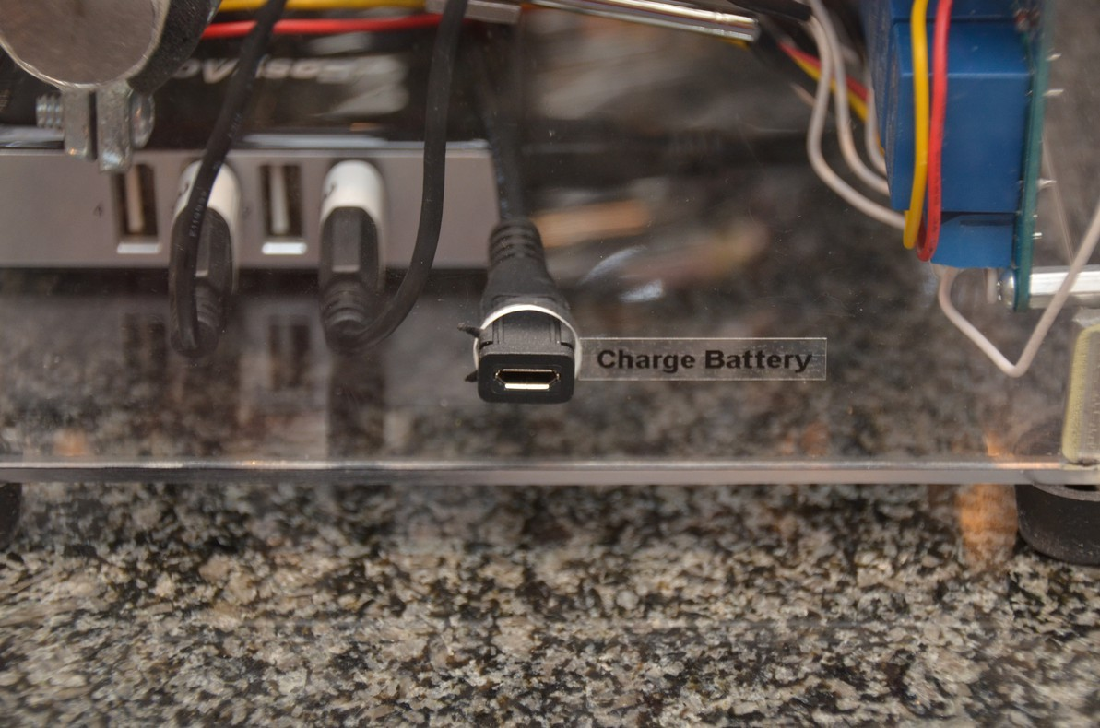There's a small micro-USB extension cable from the battery pack's charging port to a hole on the right side of the case. The battery should be recharged after using the IV Swinger. Any micro-USB charger can be used (cell phone, e-reader, etc). The battery is charged when all four of its blue LEDs are lit and none is blinking.

**Innards**

**Raspberry Pi Model B+**

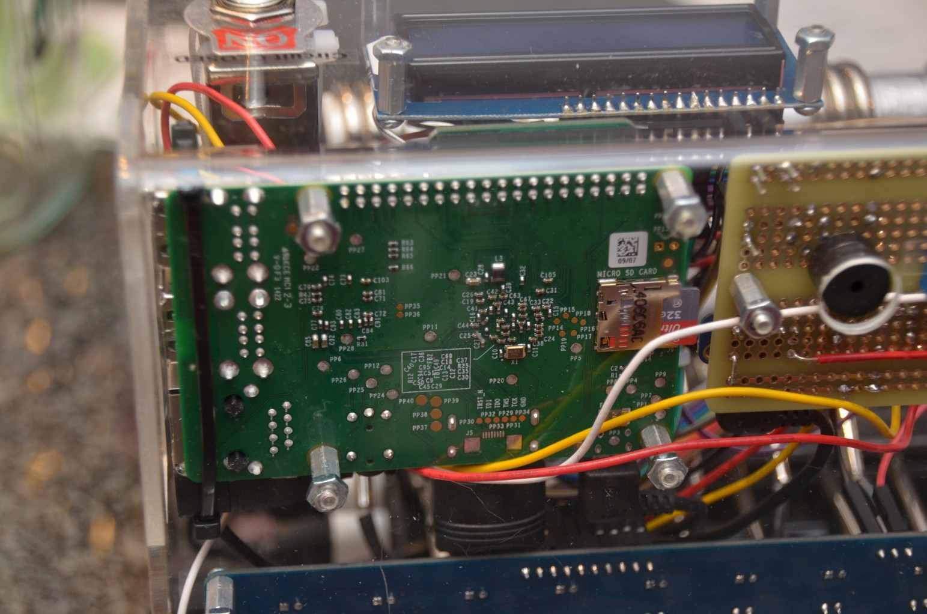

**Battery pack**

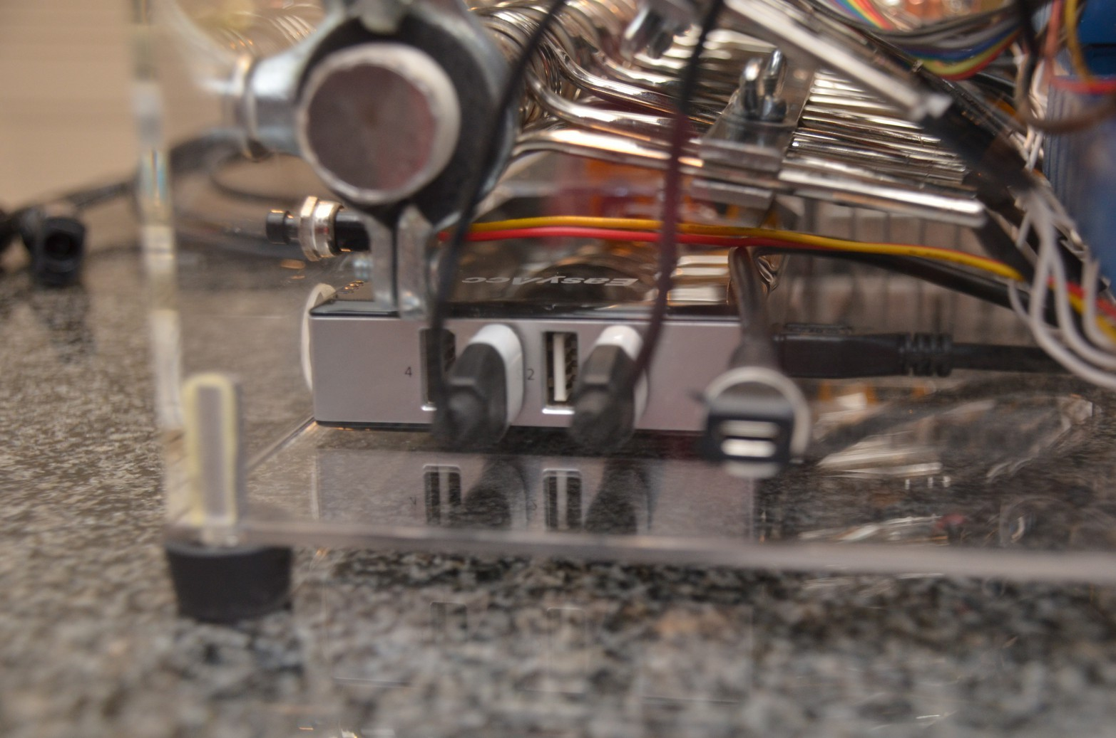

**Relays**

Controlled by the Raspberry Pi software to select or deselect each load. A relay is a physical switch operated by an electromagnet. You can hear them “click” when they switch. Each one also has a red LED that is on when the relay is selecting its load and off when its load is bypassed.

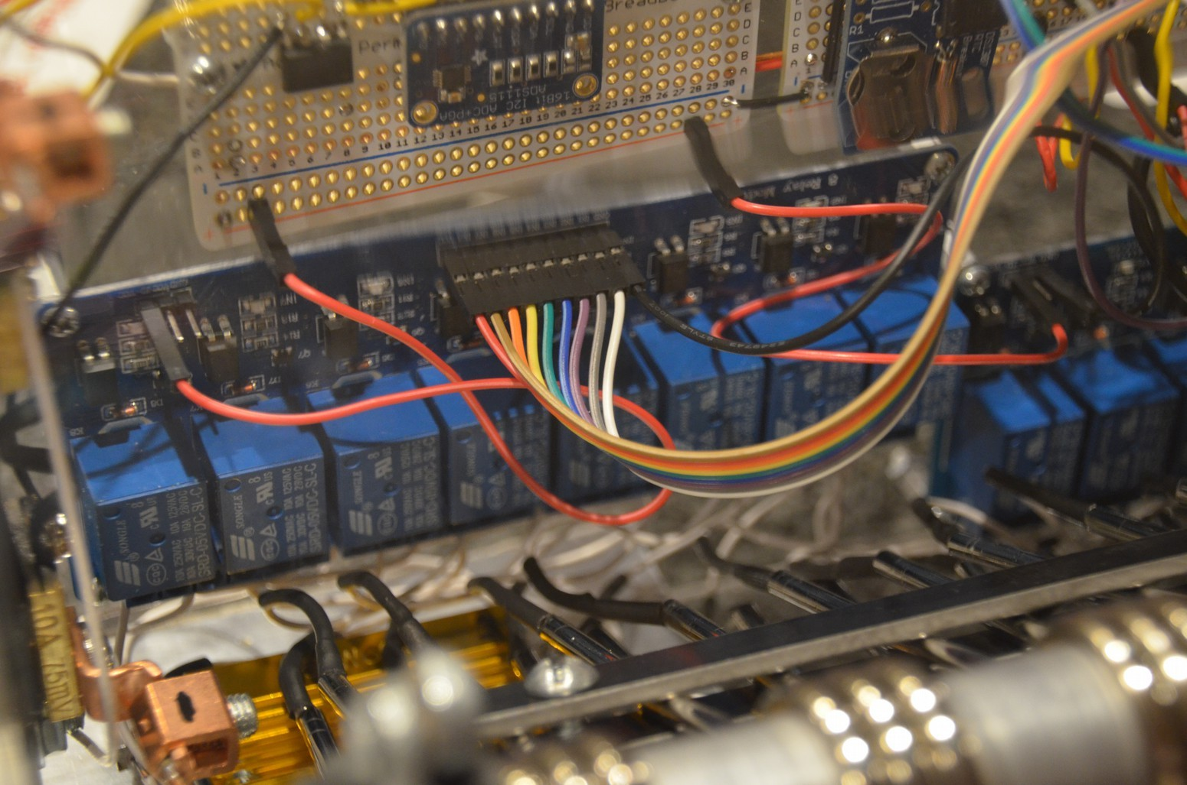

**Load bank**

These are immersion coils intended for heating a cup of water/coffee/etc. Each one has a resistance of around 0.8 ohms. The aluminum rod that passes through them helps absorb/dissipate the generated heat. The first two coils on the right end are wired in parallel and connected to the first relay. The parallel resistance is around 0.4 ohms, so this “half load” is used to provide more resolution in the curve where it is needed. In order to prevent this relay from wearing out much faster than the others, the software only uses it when the curve is “bending” and does not use it on the linear parts.

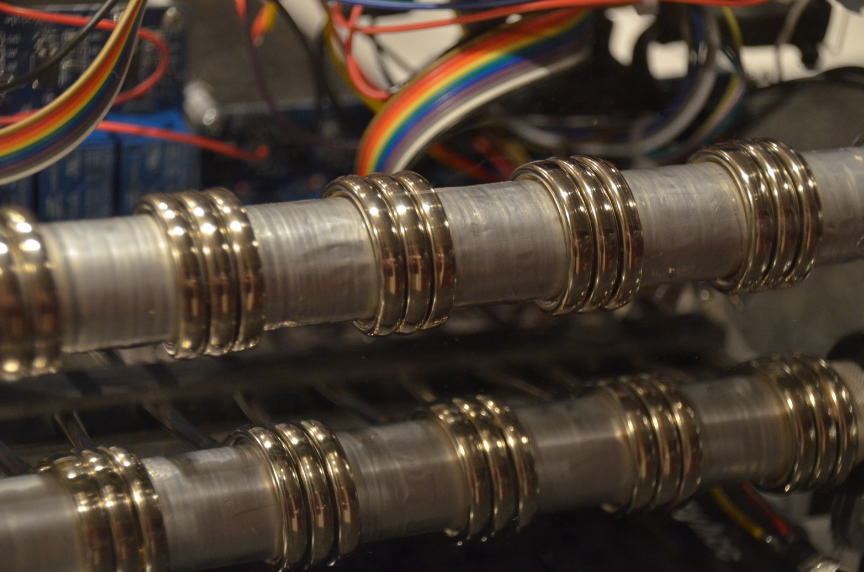

There are also five 6 ohm power resistors attached to an aluminum heat sink on the bottom left end of the case. Two are wired in parallel (3 ohms), one by itself (6 ohms), and two in series (12 ohms). These are connected to the last three relays. Higher resistances are needed at the end of the range in order to get any meaningful separation between the points (look at the picture of the curve in the Introduction above to see this). They are also sometimes used at the beginning of the curve when Isc is very low compared to Voc in order to “push” the fine-grained loads to the knee of the curve.

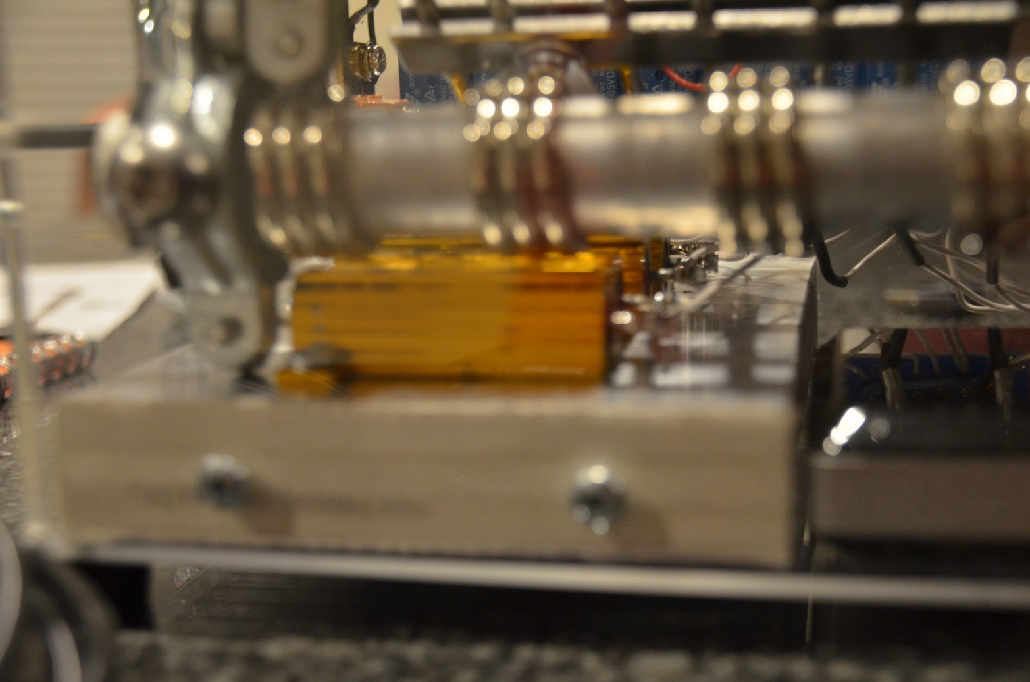

**Circuit boards**

The two white “permaproto” boards to the left of the Raspberry Pi contain the following necessary electronics:

• Analog-to-Digital Converter (ADC) for voltmeter and ammeter

• Voltage divider circuit to scale PV voltage down to range supported by the ADC

• Op amp circuit to scale voltage across the ammeter shunt resistor up to the range supported by the ADC

• Piezo buzzer and circuit for amplification and control by Raspberry Pi

• LCD contrast potentiometer

• Battery-backed Real-Time Clock (RTC) module to allow the Raspberry Pi to keep track of the date and time without an Internet connection

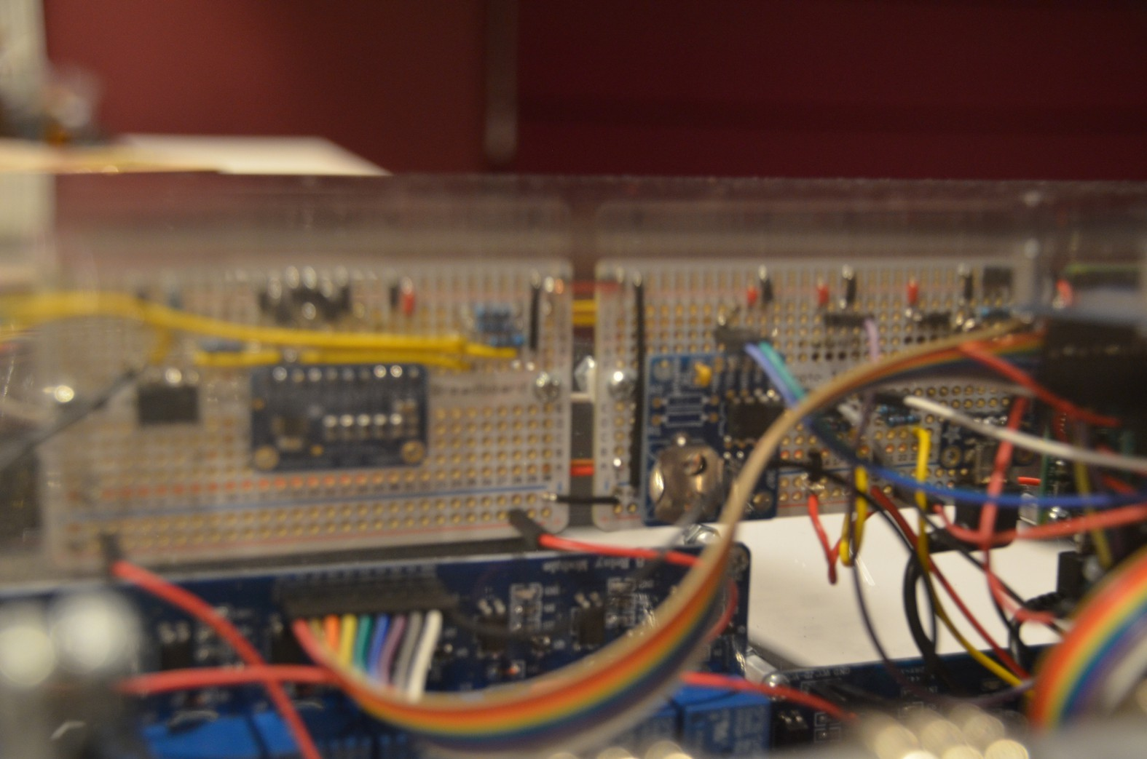

**Shunt resistor**

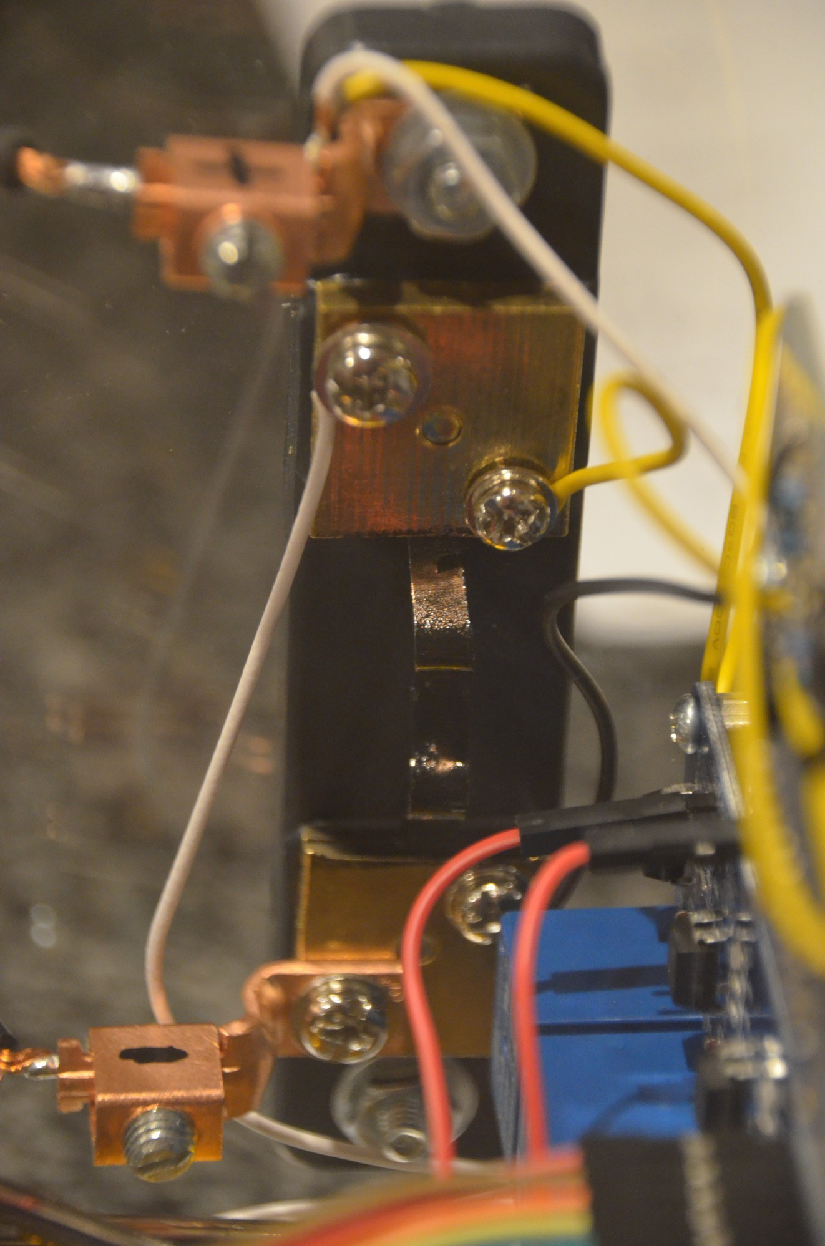This is used for the ammeter. It is a precise low-resistance resistor that is in the load circuit.

The voltage across it is measured by the ADC (after amplification by the op amp circuit). Ohm’s Law is then used to calculate the measured current.

**Output Folders and Files**

The IV Swinger creates a /IV_Swinger folder in all USB drives that it discovers. If multiple people (e.g. lab partners) are interested in the results, it can be convenient to insert multiple USB drives so each of them has a copy. There is also a /IV_Swinger folder on the Raspberry Pi's internal file system (micro-SD card, not normally accessible from outside the box). All USB drives should be inserted before starting up the IV Swinger. If the software discovers that there are no USB drives inserted when it starts up, it generates a 30-second countdown with a loud beep every second and a message to the user(s) to insert one or more USB drives. If none is inserted when the countdown expires, the IV Swinger proceeds anyway – writing its results only to the /IV_Swinger folder on its internal drive. It keeps track of these results that have never been written to a USB drive. The next time that a USB drive is found, it copies all of these “pending” results to the USB drive. So, for example, if no one brought a USB drive, the lab could continue in parallel while one person runs off to get one. And when he/she returns, all of the results captured while he/she was gone will be copied to the USB drive.

Every time the IV Swinger is started up, the software creates a log file of the whole session. This can be useful for debugging but shouldn't be interesting to the user. The log file is copied to the

/IV_Swinger/logs folder with a name like: log_150401_12_07_21. The name format is log_yymmdd_hh_mm_ss where the date and time is when the program started (after boot was done).

A separate folder is created for each curve trace captured during the session. This folder has a name like: 150401_12_07_37. The name format is yymmdd_hh_mm_ss where the date and time is when the toggle switch is turned ON to start swinging the IV curve.

The files created in each of the /IV_Swinger/yymmdd_hh_mm_ss folders are:

• data_points_ yymmdd_hh_mm_ss.csv

This is a comma-separated value (CSV) file with the measured values for Volts and Amps at each point. The calculated values for Watts and Ohms are also included. This file can be

read into a spreadsheet program such as Excel, LibreOffice Calc, or Numbers for Mac. The charting tools can then be used to generate the IV curve graph as desired by the user. Since CSV is a text file format, it is possible to edit it, combine multiple files together, analyze it with a user-written program/script, etc.

• gp_data_points_yymmdd_hh_mm_ss and gp_command_file_yymmdd_hh_mm_ss

These are text files used as input to the Gnuplot program to generate the gp_data-points.pdf file. In addition to the measured points, the gp_data_points_yymmdd_hh_mm_ss file has interpolated points used to compute the Maximum Power Point. The gp_command_file_yymmdd_hh_mm_ss contains the gnuplot commands to generate the graph. Neither of these files is intended for the user so you can ignore them.

• gp_data_points_yymmdd_hh_mm_ss.pdf

This is a PDF of the IV curve graph generated by the IV Swinger software and Gnuplot. Linear interpolation is used to estimate the Maximum Power Point (MPP). The graph looks like the one in the Introduction section above. This doesn't have the flexibility of the CSV file, but all the work has been done for you so it saves a lot of time if it meets your needs. And even if you are going to use the CSV file later it's a quick way to quickly see what the curves look like.

**Ratings and Limitations**

1. Number of times the IV Swinger can be dropped and survive: **ZERO**

… even from a few inches, much less off a roof! Future versions may be ruggedized, but this one is fragile. The case is acrylic, which will easily break if dropped. Many of the electrical connections are not soldered, but are either connected with press-on jumpers or are held with screws. A drop from any height would almost certainly cause some of these to come loose.

**DON'T DROP IT!!**

2. Maximum rated PV panel Isc: **10A**

It is not recommended to connect the IV Swinger to two or more PV panels in parallel. But if you do, remember that the currents of parallel PV panels ADD, so make sure the sum of their rated Isc values is less than 10A.

3. Maximum rated PV panel Voc: **80V**

It is not recommended to connect the IV Swinger to two or more PV panels in series. But if you do, remember that the voltages of series PV panels ADD, so make sure the sum of their rated Voc values is less than 80V.

4. Maximum temperature: **unknown**

The Raspberry Pi has no cooling and there are no fans or other cooling mechanisms in the IV Swinger case. The fact that the IV Swinger will generally be used outside in the sun and the load bank will generate some heat inside the box combine to make it likely that the temperature inside the box could get fairly high. It could exceed the temperature limits of the Raspberry Pi and cause it to crash or otherwise misbehave. This has not been characterized. It would be a good idea to try to keep the IV Swinger shaded if it is a hot sunny day.

5. Lifetime (number of IV traces until it dies): **unknown**

The relays are almost certainly the weak link. They are inexpensive, and DC switching is very tough on relays. One relay (the one controlling the “half” load) failed on the first prototype. “Snubbers” were added to the relays to mitigate arcing, but it is not known how effective this is. The relay coils may burn out.

6. Number of times you can take the IV Swinger to an airport and not get arrested: **ZERO**

It really looks like some kind of WMD doesn't it?